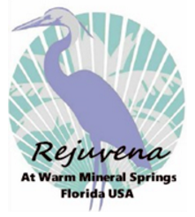
Rejuvena Warm Mineral Springs, Inc.
Health and Wellness Resort Project

Strategic Business Plan
July 30, 2017

Presented by:
Nick Nicoloff
Project Director

CONFIDENTIAL DATA
All Financials, Plans, and Business Projections contained herein are the proprietary property of RWMS, Inc., and may not be copied, shared or disclosed to any third party without written permission.

ABSTRACT

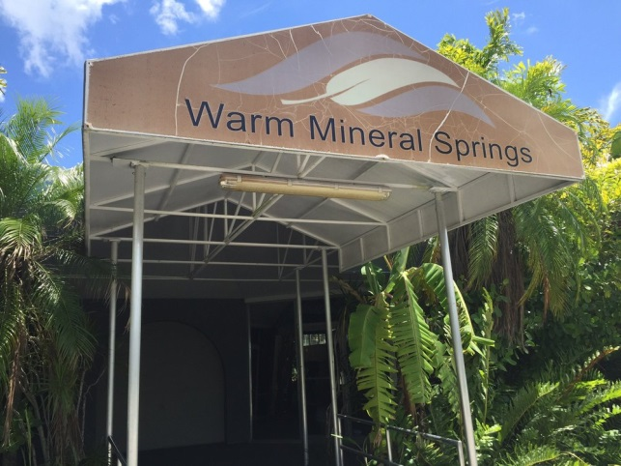
ABSTRACT

This Strategic Business Plan for Rejuvena Warm Mineral Springs, Inc., hereinafter ‘The Company’, has been prepared based upon a due diligent analysis of national industry space for Health-related Leisure and Wellness. In addition, The Company’s Business Model is based upon a Standard, 5-Year model.

Definition of Business Plan Approach:

This Business Plan is summary in nature because of the dependence on planned equity funding rather than Debt Funding or public-intent venture capital. It is for this reason that the final business formation is an ‘S’ Corp.

Financial Model and Statements:

The Planning Horizon for the business plan is Five (5) Years and, as such, reflects Goals and Objectives on an Annual basis only. Detailed, Monthly Income Statements, Balance Sheets, and Cash Flow Analysis are available upon request.

Business Plan Compliance:

This Strategic Business Plan fits the format and content requirements for its business model and is suitable for external review by Venture Capital Investors, banks and an audit of intended business operations.

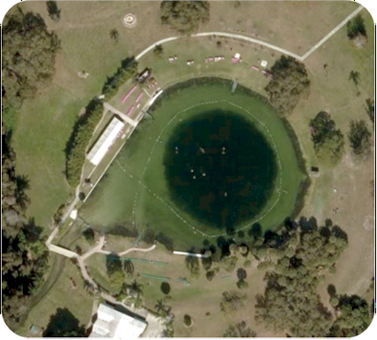

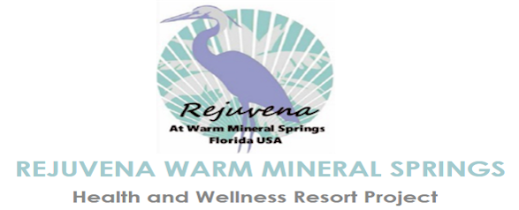

TABLE OF CONTENTS

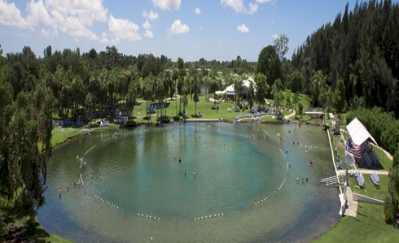

Cover Page .....................................1
Abstract..........................................2
Table of Contents...........................3
EXECUTIVE SUMMARY...................4
PROJECT ELEMENTS..………………..5
BUSINESS CONCEPT………………….6
SITE PLAN….………………………………7
ABOUT WMS….……………………………8
WELLNESS CENTER...…………………9
RESORT HOTEL..………………………11
ASSISTED LIVING CENTER..…..….12
COMMERCIAL & RESIDENTIAL
COMPLEX..……………………….……..15
MISSION & VISION ………………..…16
COMPETITION………………………….18
STRATEGIC PLAN...…………………..19
OPERATING PLAN…………………….20
MARKETING PLAN..………………….24
MANAGEMENT TEAM..………………26
FINANCIAL SUMMARY....……………27
FINANCIAL STATEMENTS..…….….29

EXECUTIVE SUMMARY

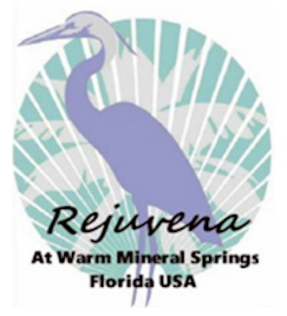

INTRODUCTION:
Many Business Plans are produced in the U.S. annually. Rarely does a business opportunity emerge that has the potential to be a national force in the Health Resort and Institute field within simply a few years. That is precisely the potential of the business that you are about to learn about. It is the result of years of intensive research and exploration by the Founder and the resulting business model and its potential are significant by any standard. The emerging business we are speaking of here is named Rejuvena Warm Mineral Springs, Inc.

BUSINESS CONCEPT:

Boasting a full 19 acres, this premier site is suited for a spa village. With tailor made natural treatments, stunning scenery and therapeutic programming, Warm Mineral Springs offers a consistently unique and uplifting opportunity for rejuvenation. Rejuvena Health and Wellness Center will include comprehensive medical/rehabilitation/physical therapy services, special dietary dining restaurant, chronic pain management and falls prevention clinic, general wellness and physical therapy programs, as well as other comprehensive health and wellness programs provided in cooperation with the local government, and other renowned health and hospitality institutions. Rejuvena Health and Wellness Center will be situated in two, three story buildings. The ground levels will house medical and physical therapy spaces and dietary dining restaurant. The second and third floors will contain a substantial number of rooms and suites for the short term visitor stay.
With this in mind, the Owner of the land, and Nick Nicoloff of Atlantic Global Realty and Management have joint- ventured to bring together a spa village with a variety of health and wellness services. Additional components include, including the health and wellness institute is the introduction of a medical hotel, assisted living service and mixed used development for residential and commercial customers. The integration of these services is expected to begin in the first half of 2018, provided investors are acquired in a timely manner.

SUMMARY OF PROJECT ELEMENTS

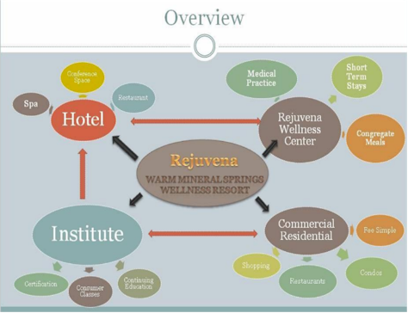
Rejuvena Warm Mineral Springs Health and Wellness Resort is conceived as a multi-function medical and wellness complex, consisting primarily of 125 bed Rejuvena Resort Hotel, an ambulatory and short-stay Rejuvena Health and Wellness Center with an anti-aging spa, a wellness institute and commercial area, with total buildable space of at least 330,000 sq. ft., and residential village of up to 72 residential, multi-family units and an 80-Bed Assisted Living Center.
Rejuvena will be built on 19 acres immediately adjacent to the historic Warm Mineral Springs -- the internationally renowned geothermal mineral springs located in North Port, Sarasota County, Florida.

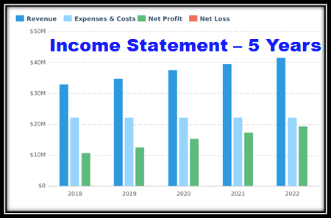
PROJECT ELEMENTS:
1. RESORT HOTEL:
125 Room Lifestyle/Boutique Brand Hotel catering to upscale Clientele interested in Health/Wellness.

2. REJUVENA WELLNESS CENTER:
An Institute-level Center for Spa and other Health-related Wellness Services focusing on the Warm Mineral Springs health characteristics.

3. ASSISTED LIVING CENTER:
An 80 Bed/Suite Senior Assisted Living Center also utilizing the health-giving characteristics of Warm Mineral Springs.

4. COMMERCIAL/RESIDENTIAL CENTER:
A full-scale Commercial and Residential Center with shops, business services, and 72 residential multifamily units.

A residential care solution with fully integrated health services including
supervisory, personal, or directed care on a continuing basis for older
adults needing the additional support.

SUMMARY OF BUSINESS CONCEPT

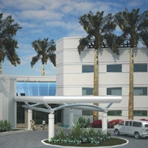
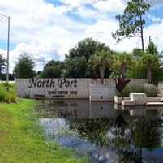
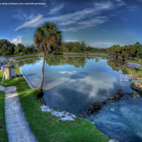

OPPORTUNITY
The Rejuvena Project now invites the participation of investors, and developers, medical practitioners, hotel operators, businesses and restauranteurs, to explore these unique opportunities.

THE LOCATION
Located in Northport, Florida in Sarasota County, on the border of Charlotte County, the Rejuvena Project is ideally situated in Central Florida's tourist, leisure residential and retirement region.

THE SPRINGS
Rejuvena's proximity to the renowned Warm Mineral Springs is expected to bring immediate visibility to the project. The Warm Mineral Springs contain proven, health-giving properties.

SITE PLAN – Overview
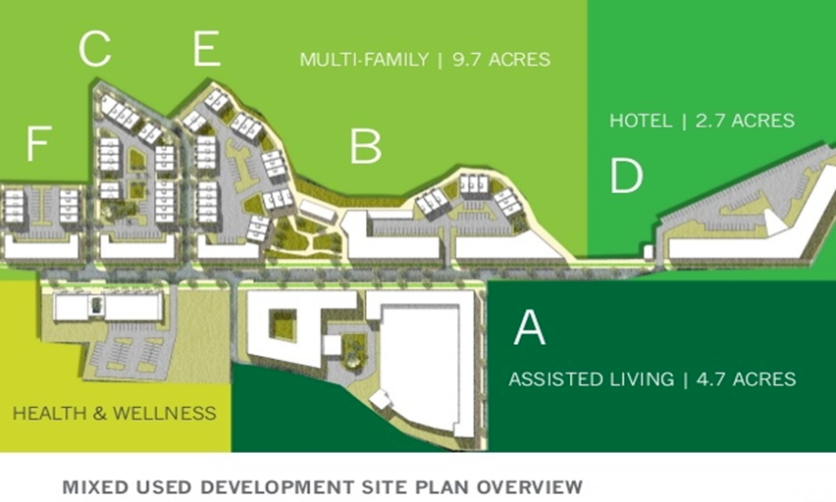

SITE PLAN – Aerial

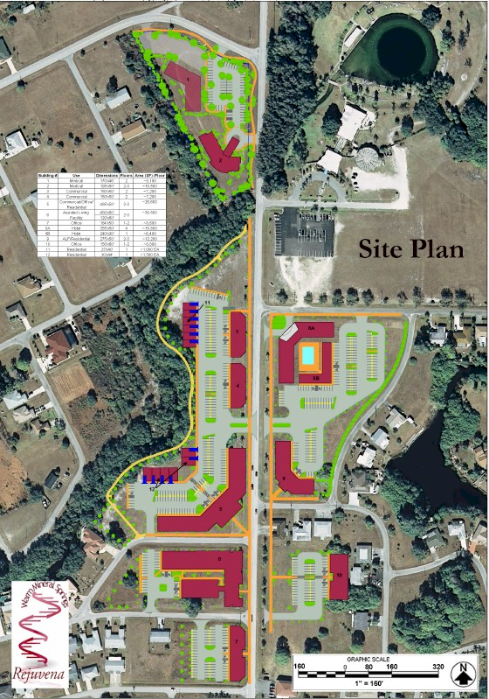

ABOUT WARM MINERAL SPRINGS

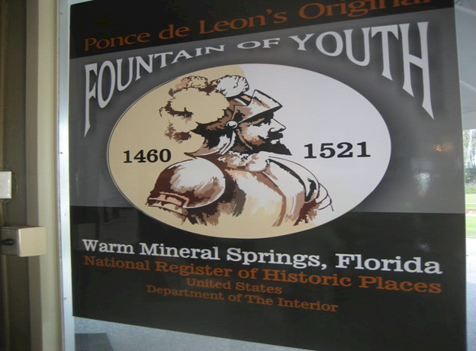

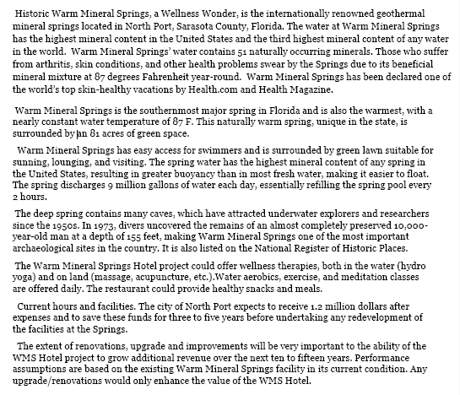

THE WELLNESS CENTER

The Company’s primary Focus is the top four business Sectors in the Health & Wellness Industry – the Resort Hotel; the Wellness Center; the Assisted Living Center; and the Residential & Commercial Center. It has the potential of generating extremely high profit margins for competitive players.
[Note: The Wellness Center, specifically, has already been funded – but its After-Investor-Return Net Income is included in the overall Financial Statements.]

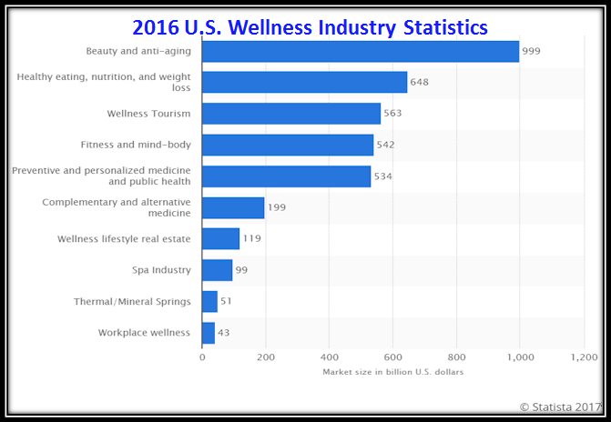

THE WELLNESS CENTER [CONT’D]

WELLNESS CENTER - LAYOUT
WELLNESS CENTER - CONCEPTUAL LAYOUT

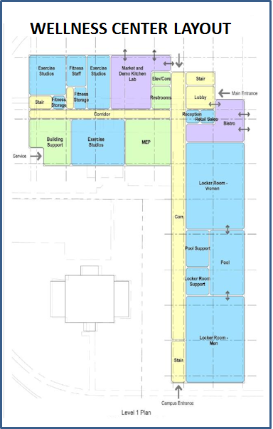
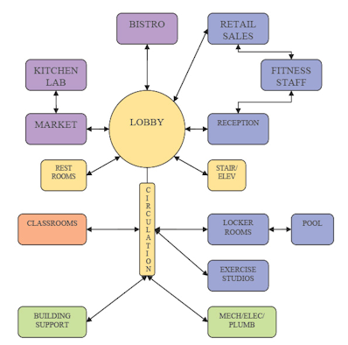

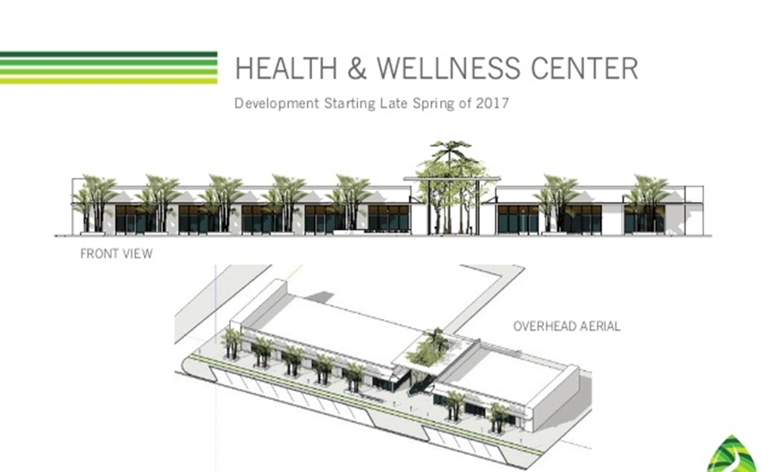

THE RESORT HOTEL [Cont’d]

As this graphic presents, the vast majority of Resort Hotel Revenues – 55% are generated at Upscale establishments – the Company’s primary Hotel characteristic. It is for this reason that both Midscale and Luxury Hotel definitions are clearly not a fit for the Company’s Vision. There is also a fix between Upscale Housing and Mineral Spring Health Interests worldwide.

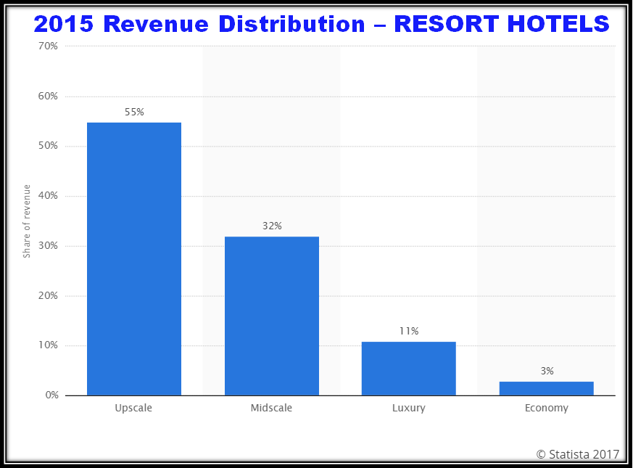

THE RESORT HOTEL [CONT’D]

RESORT HOTEL ELEMENTS:
- 125 Rooms Lifestyle/Boutique Brand Hotel
- 25 Extended Stay Type Suites
- Full Service Restaurant
- Full Service Spa
- Heated Pool
- Flexible Meeting Space
- Four Star Designation

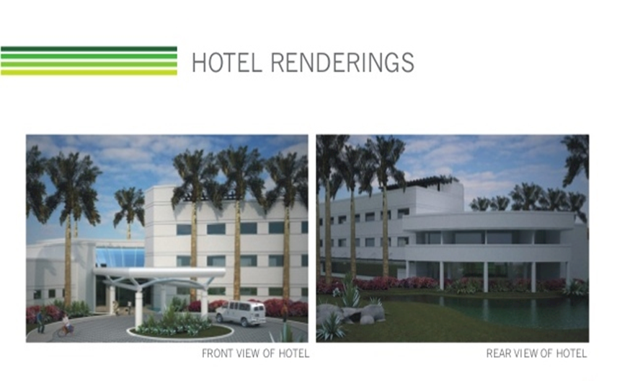

THE ASSISTED LIVING CENTER

The validity and importance of these Data is their reflection on the relatively constant state of growth in recent years, in the Assisted Living Industry. Since 2012, this Industry space has seen a constant 5% growth factor, which bodes well for the Rejuvena Business.

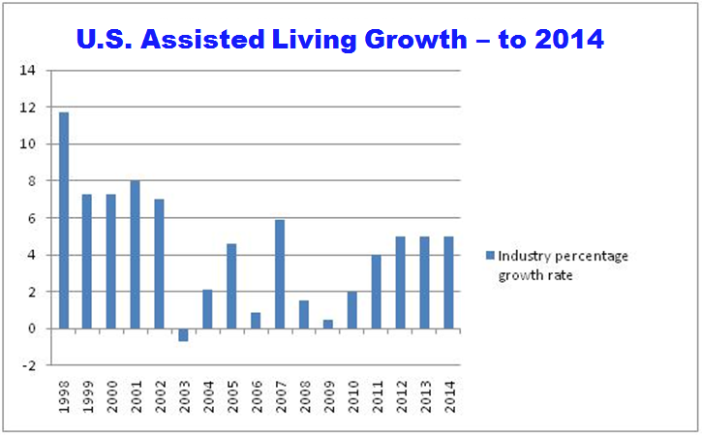

THE ASSISTED LIVING CENTER [CONT’D]

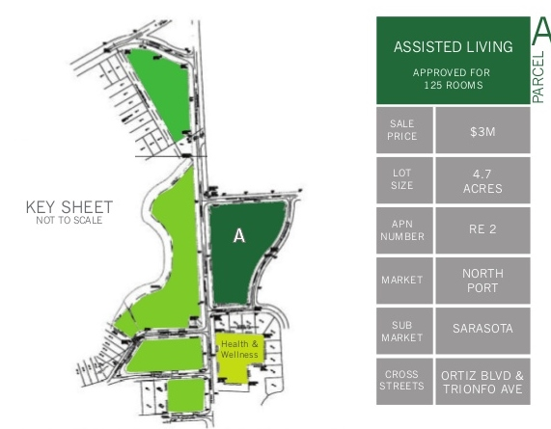

THE COMMERCIAL COMPLEX

The Commercial Complex will be a 2-story layout, approximately 16,000 sf, supporting both Retail and Commercial/Business venues – both of which provide overall support to the Rejuvena Complex. Assuming a Construction/Build Cost of $175/sf, the Total Investment in Construction will be approximately $2.8 Million.

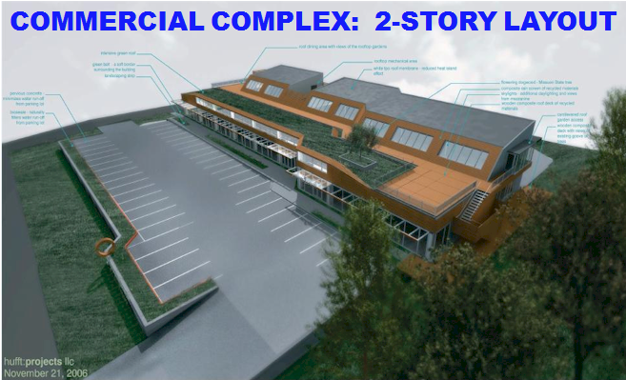

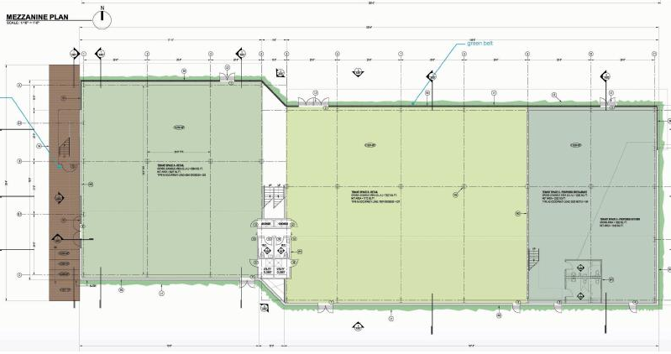

MISSION AND VISION

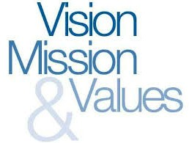

MISSION STATEMENT:
To bring about realization of all the required elements for maximum utilization of the natural wonder of Warm Mineral Springs, in North Port, Sarasota County, Florida, and in so doing, to make the life-giving and health benefits of the WMS available to all mankind.
VISION FOR THE FIRST 5 YEARS:
The mixed use Rejuvena development project will focus on fully developing the WMS Wellness Resort, which will be a unique destination for the national and global health and wellness tourism industry.
The Health and Wellness Center is underway, and while separately funded, its residual net income – after Investor restoration – will also contribute to the overall financial returns of Rejuvena. A three-phase approach will include medical offices, a Hotel, Assisted Living Center and Commercial/Residential complex.

COMPETITION

Competitive Insights
There are no other Warm Water Mineral Springs anywhere in the State of Florida. While there are certainly other Resort Hotels and venues in the general category of Wellness in west-central Florida – none represent any real competition for Rejuvena. Therefore, further research on the state of competition is not needed or presented.

STRATEGIC PLAN

PRIMARY GOALS & OBJECTIVES:
- To bring together in one place all the business elements to make the Rejuvena Project successful.
- Obtain First Round funding to acquire and build out all the structural elements of Rejuvena and supply the Cash Flow for Operating Expenses for the first year.
- Year 5 Gross Sales of $42 Million and EBITDA of 40+ % of Sales.
- Achieve Year 3 Profitability.
- Achieve a Website Page Rank of ‘5’ and 10000 Page Views per month in the first year.
- Debt free during the business plan timespan.

KEYS TO SUCCESS:
- Providing consistently excellent delivery of Upscale Hotel, Wellness Institute and Assisted Living capabilities.
- Create sufficient branding recognition to attract a constantly increasing Client-User and Customer base.
- Successfully demonstrate the delivery of creative, new technology models – all of which focus on the Health-giving traits of the Rejuvena Warm Mineral Springs.
- Successful, Company-owned facilities and equipment.

OPERATING PLAN

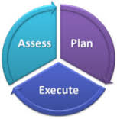
OPERATIONAL PLANS:
The primary plans for the operation of the business in year one include the rapid establishment of the headquarters facility and all the Construction efforts necessary to complete erection and buildout in the planned timeframe. Priority one after the onset of operations is to acquire all the Capital Assets – primarily Furniture, Computers, Lab, Wellness, Research and related equipment.

In early 2018 we will establish Call Center Operations and lease cloud-based data storage and access capabilities.

In addition, the recruitment and training of all professional personnel will take place. A team will be necessary when we begin to support Call Center-driven Hotel reservations.

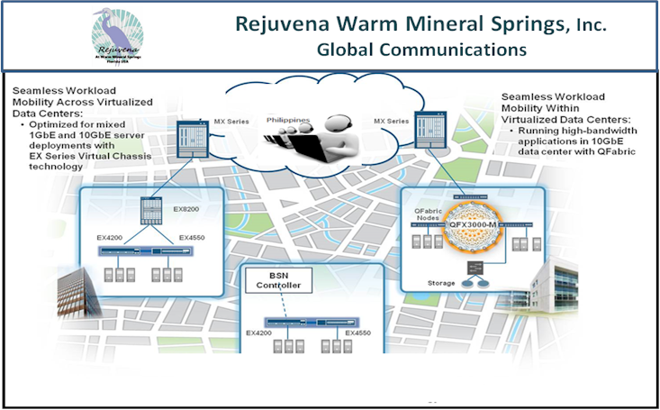

Global Business Operations

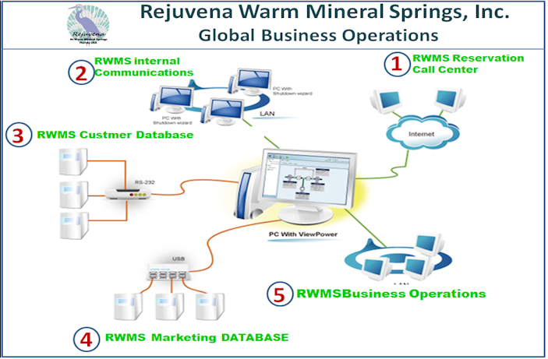

Operating Framework

OPERATING FRAMEWORK:
In any organization, it is necessary for everyone to congruent as regards how the operating environment will function and flow. There need to be established Processes that will be followed as well as written, standard Policy & Procedures that are to be utilized in every situation requiring consistency and control. These need to be tied to the authorizing elements of the Strategic Plan so that resources are dedicated by priority, by time period, by department. The following graphic reflects the process that the Company will follow:.

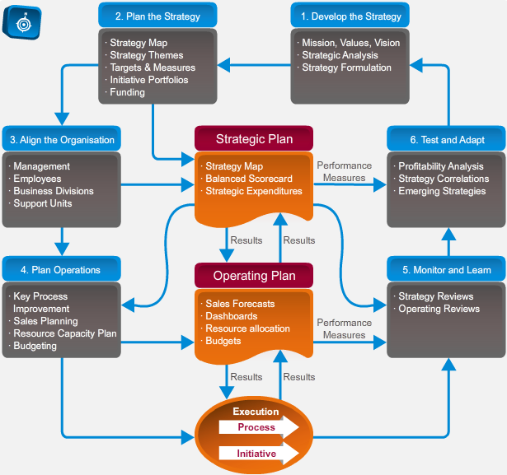

OPERATING DEPARTMENTS:
As with any modern Office Facility, the business operations of the Company will be fully supported by global communications, database management, and the latest Information Technology equipment.

The Company also intends to utilize a Call Center for the management of inbound calls from its potential Hotel, Wellness Center and Assisted Living Customers. It will re-route to websites/offices at Headquarters (HQ).

The primary need for Training and Development will begin in the third year - for the personnel who will be involved in for selling and servicing all reservation-based services. Beyond the first year, there will be training for contract and billing done by the HQ staff.

The primary operating plan regarding staffing in year three includes rapidly staffing the Headquarters organization for robust execution of the full operating plan, once buildout has been concluded. Our target hires for the Company in Years 2, 3 and 4 will need to have either Hotel, Leisure or Assisted Living Sales experience. It goes without saying that a sincere dedication to superior quality in the Leisure industry is also a prerequisite. Hiring will be consistent with the continuing rise in demand. The Owner feels that he will not require any paid advertising for these hires in the first two years.

MARKETING PLAN

MARKETING ELEMENTS:

The test is intended for use in patients diagnosed with CML to help predict treatment-free and
recurrence-free survival. The test provides: 1) a quantitative assessment of the likelihood of
both late (post-5 years) recurrence following an initial 5 years of TKI therapy, and 2)
adjunct treatment requirements in addition to TKI, based on identification of progenitor
cells. The results are adjunctive to the ordering physician’s workup; treatment decisions require
correlation with all other clinical findings.
We will develop reagents and test kits, i.e. SCALPEL
TM
-based in vitro diagnostic (IVD) assays
for allergy and auto-immune diagnostics. The kits will be distributed through corporations
specializing in diagnostic reagents and instrumentation for research and clinical applications.
These include Baxter, Becton Dickinson, Illumina, Roche-Ventana, etc..
The CytoNuage
TM
server will be licensed to flow and mass cytometry users, who will have
The test is intended for use in patients diagnosed with CML to help predict treatment-free and
recurrence-free survival. The test provides: 1) a quantitative assessment of the likelihood of
both late (post-5 years) recurrence following an initial 5 years of TKI therapy, and 2)
adjunct treatment requirements in addition to TKI, based on identification of progenitor
cells. The results are adjunctive to the ordering physician’s workup; treatment decisions require
correlation with all other clinical findings.
We will develop reagents and test kits, i.e. SCALPEL
TM
-based in vitro diagnostic (IVD) assays
for allergy and auto-immune diagnostics. The kits will be distributed through corporations
specializing in diagnostic reagents and instrumentation for research and clinical applications.
These include Baxter, Becton Dickinson, Illumina, Roche-Ventana, etc..
The CytoNuage
TM
server will be licensed to flow and mass cytometry users, who will have
The First Year Marketing efforts will be in the direction of typical Campaigns of those supporting Resort Hotels, Wellness Centers, and Assisted Living. We plan to rely heavily on both Google Adwords and Social Media to bring in calls to the Call Center from all those interested in Upscale Health-interest and Health-related Customers.
As the buildout of all elements is completed, we will then begin to launch focused ad campaigns, Digital Media Marketing, Videos and Webinars.
In Year 3 we will launch expanded Internet and perhaps Cable Commercials to expand the reception of our message worldwide. Expansion beyond those listed here will be based on Revenue and overall response received.

​

CORPORATE WEBSITE:

MANAGEMENT TEAM

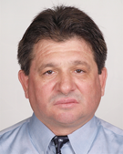

Nicholas N. Nicoloff, MD, MS, PA-C, FCTS, has worked at major healthcare institutions around the world. His experience includes clinical and experimental research, educational training, teaching and management of Startup Medical Business, medical businesses, entities and facilities, and patient care and treatment for a wide range of hospitals including Mt. Sinai/St. Luke’s Roosevelt Hospital, Richmond University Medical Center, Long Island College Hospital, Lutheran Hospital, St. Francis Hospital, San Juan De Dios Children’s Hospital, Caracas, Venezuela, St. Catherine University Cardiac and Vascular Hospital/Sofia, Bulgaria and Tohoku University Hospital/Sendai, Japan.

NICHOLAS NICOLOFF
PROJECT DIRECTOR, MD, MS, PA-C, FCTS
Operation & Management
(917) 388-7644 Cell
​(877) 317-3177 Office
AGR, LLC
nickmd1@gmail.com
www.atlanticglobalrealty.org

FINANCIAL SUMMARY

FUNDING REQUIREMENT:
The Company is a startup and the Founder is seeking First Stage Funding in the amount of $43 Million. Second Stage Funding will be in the range $__ Million. While the Company is open to multiple Investment Scenarios, the preferred target Investor is an Angel Investor or Venture Capital – probably focused on the Leisure Industry.

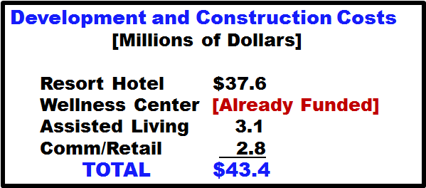

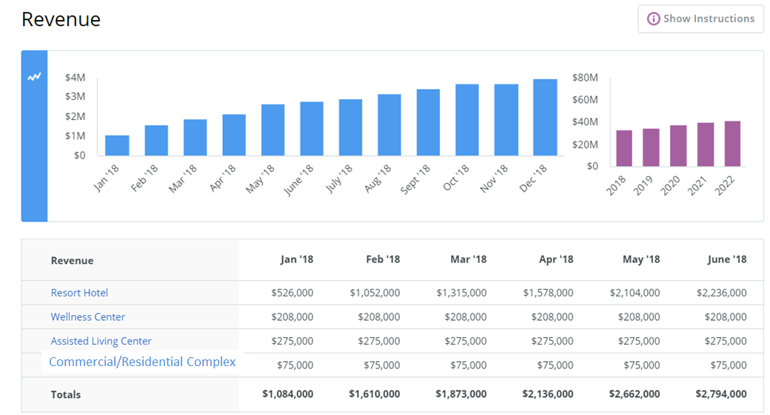

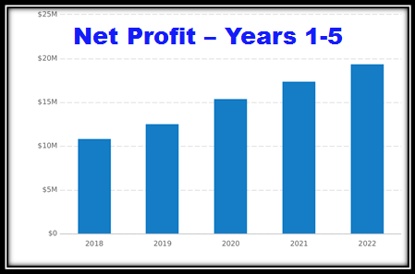
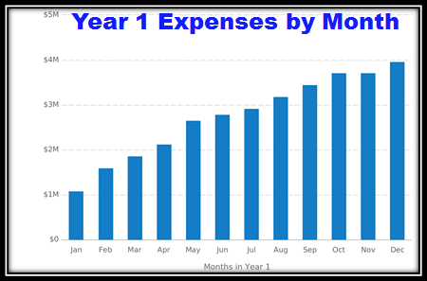

Financial Statements

Projected Profit & Loss
 | 2018 | 2019 | 2020 | 2021 | 2022
Revenue | $33,128,000 | $34,846,000 | $37,696,000 | $39,696,000 | $41,696,000
Direct Costs
Gross Margin | $33,128,000 | $34,846,000 | $37,696,000 | $39,696,000 | $41,696,000
Gross Margin % | 100% | 100% | 100% | 100% | 100%
Operating Expenses
Salary
Employee Related Expenses
G&A Expense | $19,800,000 | $19,800,000 | $19,800,000 | $19,800,000 | $19,800,000
Total Operating Expenses | $19,800,000 | $19,800,000 | $19,800,000 | $19,800,000 | $19,800,000
Operating Income | $13,328,000 | $15,046,000 | $17,896,000 | $19,896,000 | $21,896,000
Interest Incurred
Depreciation and Amortization | $2,455,000 | $2,455,000 | $2,455,000 | $2,455,000 | $2,455,000
Income Taxes | $0 | $0 | $0 | $0 | $0
Total Expenses | $22,255,000 | $22,255,000 | $22,255,000 | $22,255,000 | $22,255,000
Net Profit | $10,873,000 | $12,591,000 | $15,441,000 | $17,441,000 | $19,441,000
Net Profit / Sales | 33% | 36% | 41% | 44% | 47%

Projected Balance Sheet
 | 2018 | 2019 | 2020 | 2021 | 2022
Cash | ($35,772,000) | ($20,726,000) | ($2,830,000) | $17,066,000 | $38,962,000
Accounts Receivable | $0 | $0 | $0 | $0 | $0
Inventory
Other Current Assets
Total Current Assets | ($35,772,000) | ($20,726,000) | ($2,830,000) | $17,066,000 | $38,962,000
Long-Term Assets | $49,100,000 | $49,100,000 | $49,100,000 | $49,100,000 | $49,100,000
Accumulated Depreciation | ($2,455,000) | ($4,910,000) | ($7,365,000) | ($9,820,000) | ($12,275,000)
Total Long-Term Assets | $46,645,000 | $44,190,000 | $41,735,000 | $39,280,000 | $36,825,000
Total Assets | $10,873,000 | $23,464,000 | $38,905,000 | $56,346,000 | $75,787,000
Accounts Payable | $0 | $0 | $0 | $0 | $0
Income Taxes Payable | $0 | $0 | $0 | $0 | $0
Sales Taxes Payable | $0 | $0 | $0 | $0 | $0
Short-Term Debt
Prepaid Revenue
Total Current Liabilities | $0 | $0 | $0 | $0 | $0
Long-Term Debt
Total Liabilities | $0 | $0 | $0 | $0 | $0
Paid-in Capital
Retained Earnings |  | $10,873,000 | $23,464,000 | $38,905,000 | $56,346,000
Earnings | $10,873,000 | $12,591,000 | $15,441,000 | $17,441,000 | $19,441,000
Total Owner's Equity | $10,873,000 | $23,464,000 | $38,905,000 | $56,346,000 | $75,787,000
Total Liabilities & Equity | $10,873,000 | $23,464,000 | $38,905,000 | $56,346,000 | $75,787,000

Projected Cash Flow Statement
 | 2018 | 2019 | 2020 | 2021 | 2022
Net Cash Flow from Operations
Net Profit | $10,873,000 | $12,591,000 | $15,441,000 | $17,441,000 | $19,441,000
Depreciation and Amortization | $2,455,000 | $2,455,000 | $2,455,000 | $2,455,000 | $2,455,000
Change in Accounts Receivable | $0 | $0 | $0 | $0 | $0
Change in Inventory
Change in Accounts Payable | $0 | $0 | $0 | $0 | $0
Change in Income Tax Payable | $0 | $0 | $0 | $0 | $0
Change in Sales Tax Payable | $0 | $0 | $0 | $0 | $0
Change in Prepaid Revenue
Net Cash Flow from Operations | $13,328,000 | $15,046,000 | $17,896,000 | $19,896,000 | $21,896,000
Investing & Financing
Assets Purchased or Sold | ($49,100,000)
Investments Received
Change in Long-Term Debt
Change in Short-Term Debt
Dividends & Distributions
Net Cash Flow from Investing & Financing | ($49,100,000)
Cash at Beginning of Period | $0 | ($35,772,000) | ($20,726,000) | ($2,830,000) | $17,066,000
Net Change in Cash | ($35,772,000) | $15,046,000 | $17,896,000 | $19,896,000 | $21,896,000
Cash at End of Period | ($35,772,000) | ($20,726,000) | ($2,830,000) | $17,066,000 | $38,962,000

